**JDK Installation**

* Search oracle java on google.

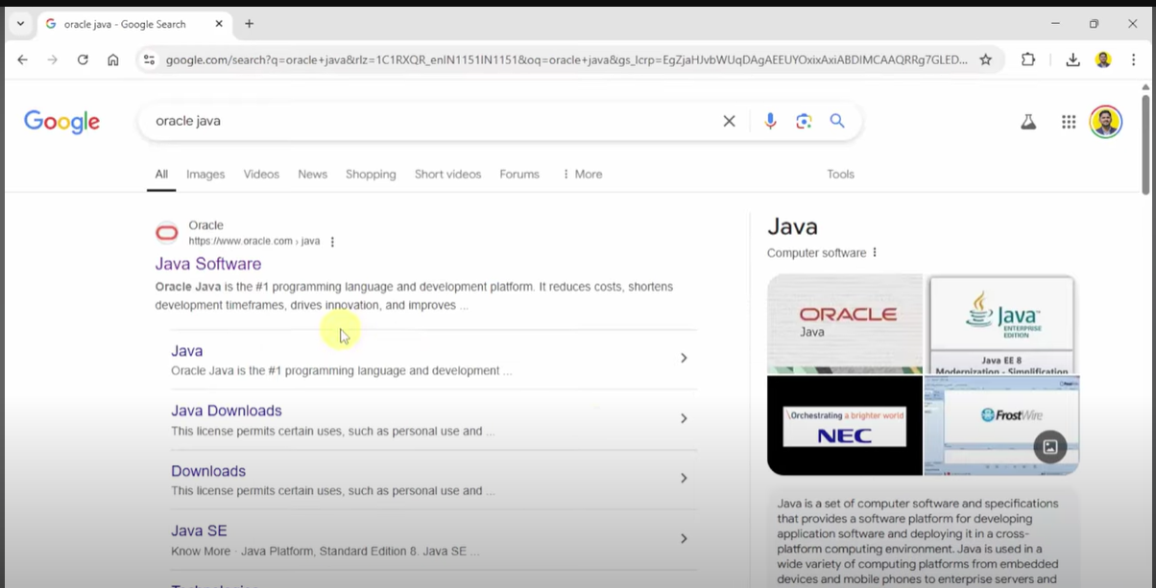

* Got to the official site and click on download java.

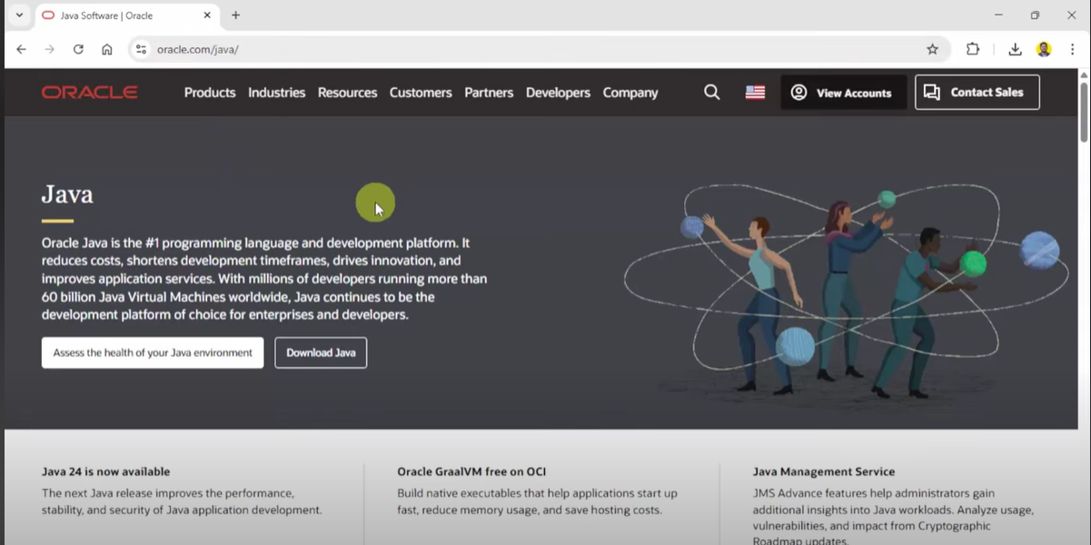

* Select JDK 24 from top left and choose widows

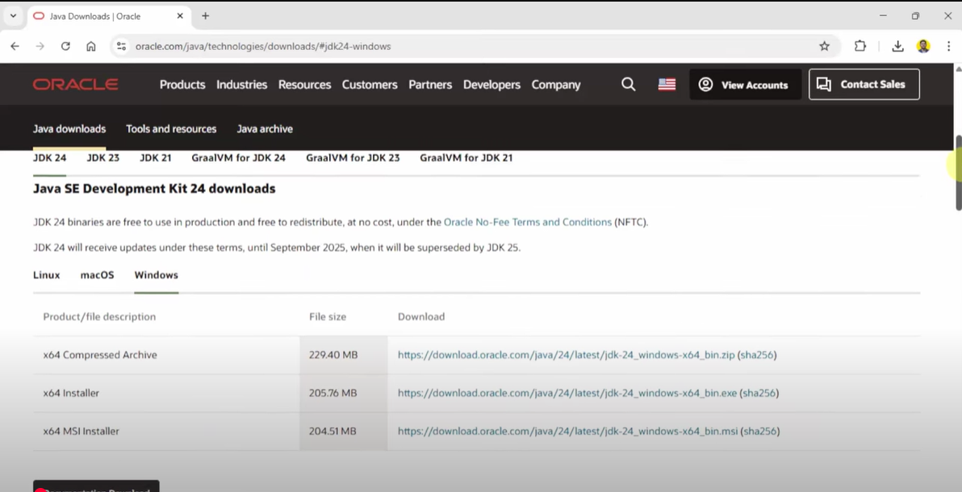

* Press on any download link.
* Run the installer, press next.

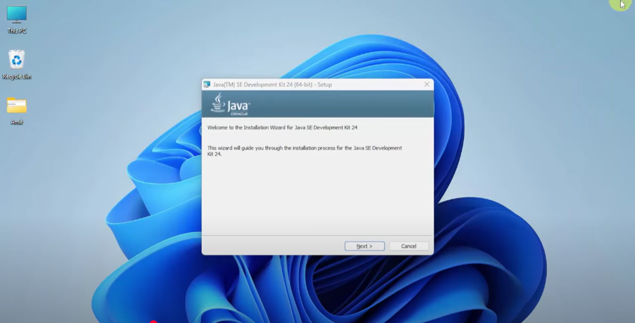

* Set the installation directory, then press next.

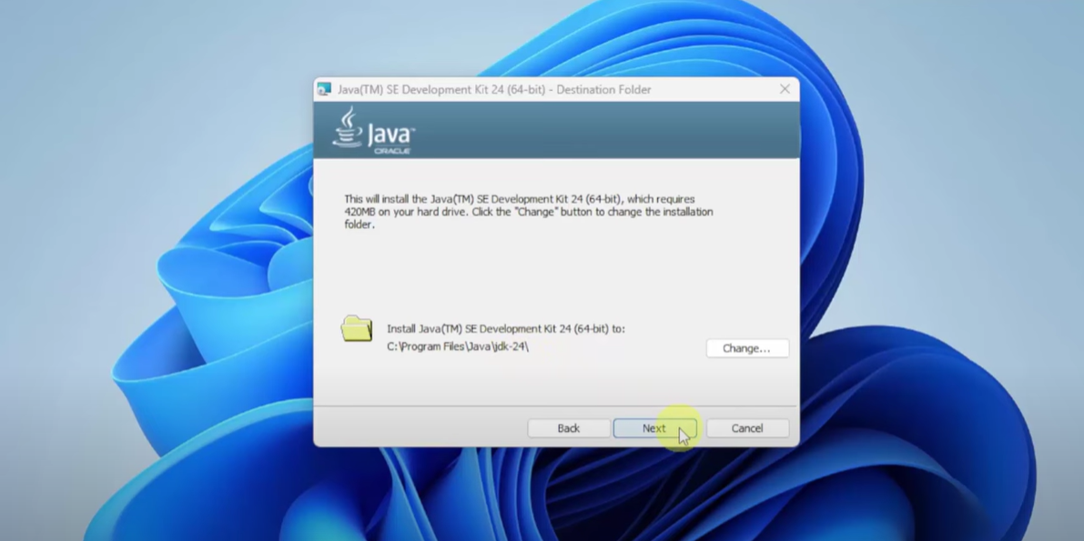

* Let it install.

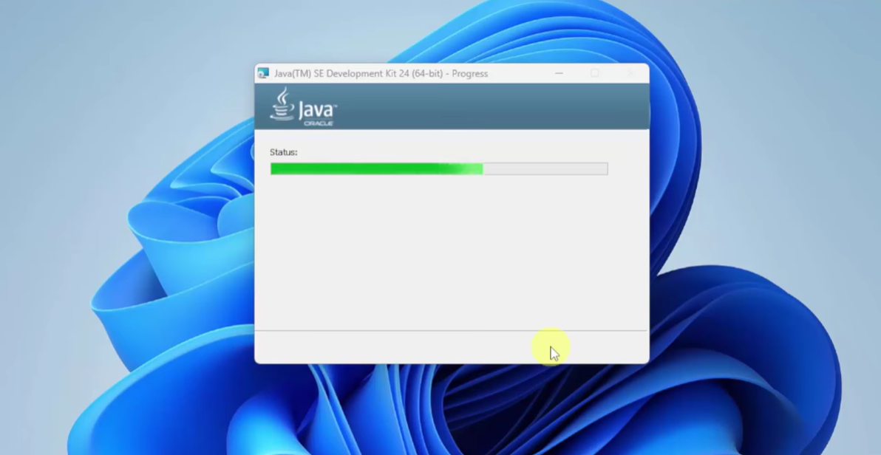

* Copy the directory c:/program files/java/jdk-24/bin and paste to environment variables.

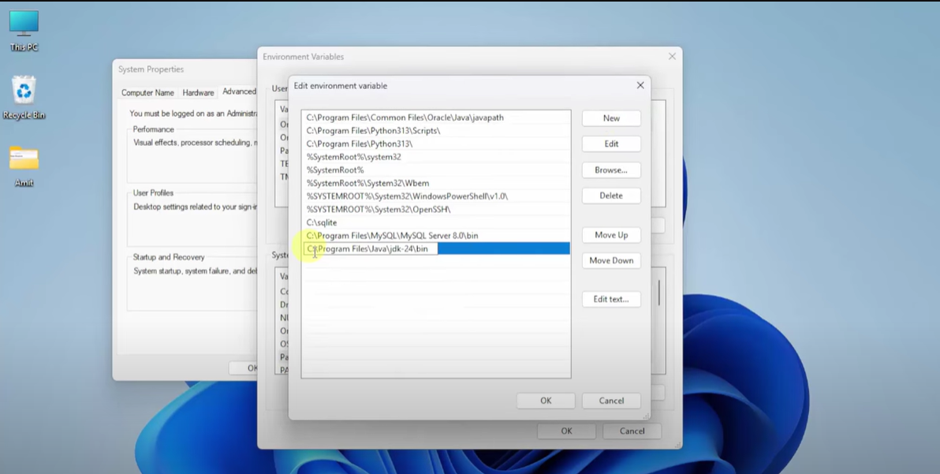

**Eclipse installation**

* Search eclipse on google and go to the official site

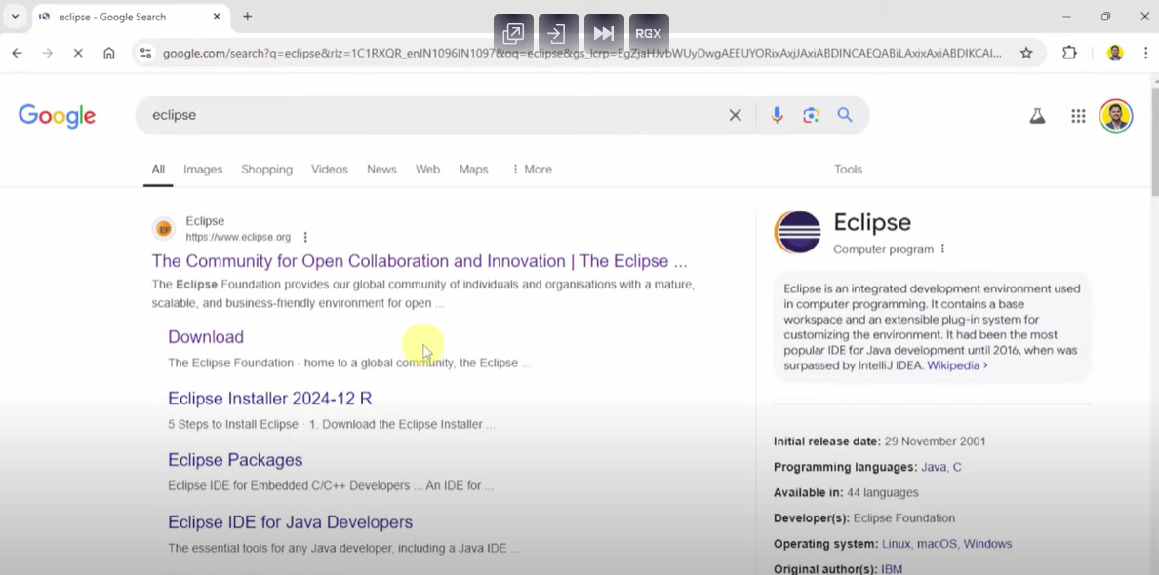

* Go to official site then press on download.

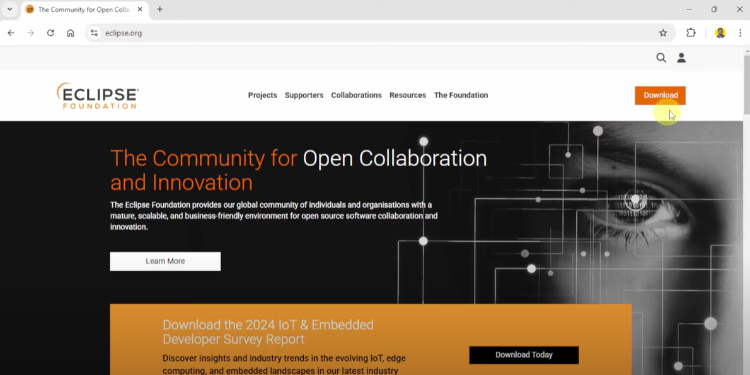

* Press on download button

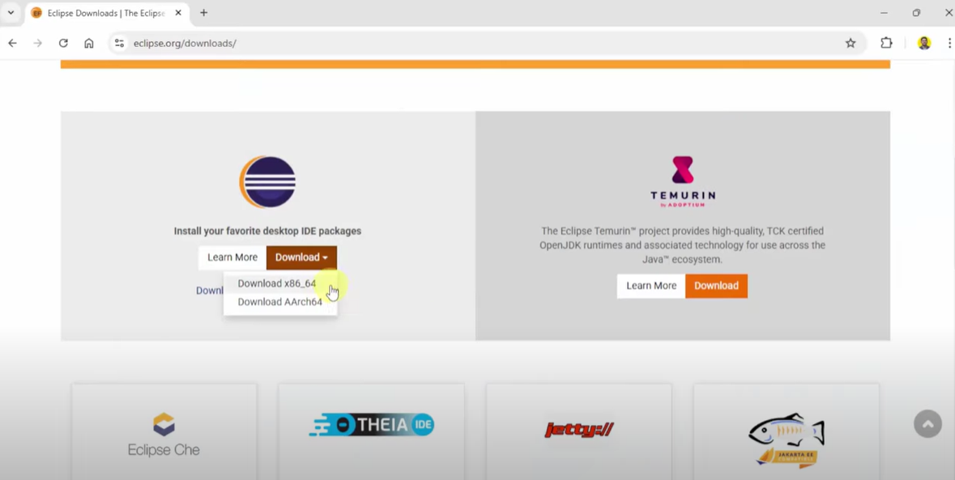

* Again press download and your download should begin.

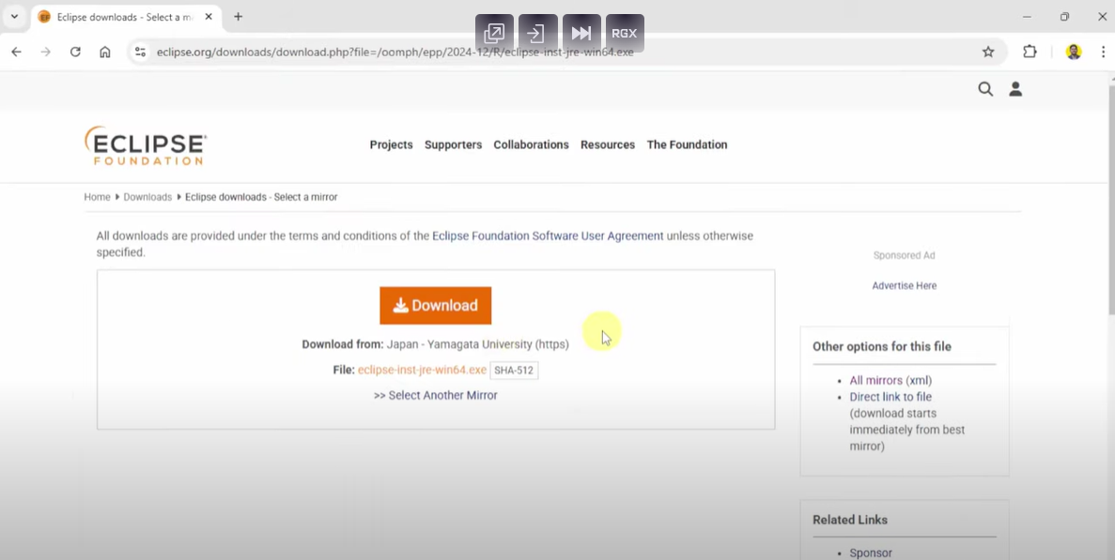

* Run the installer file

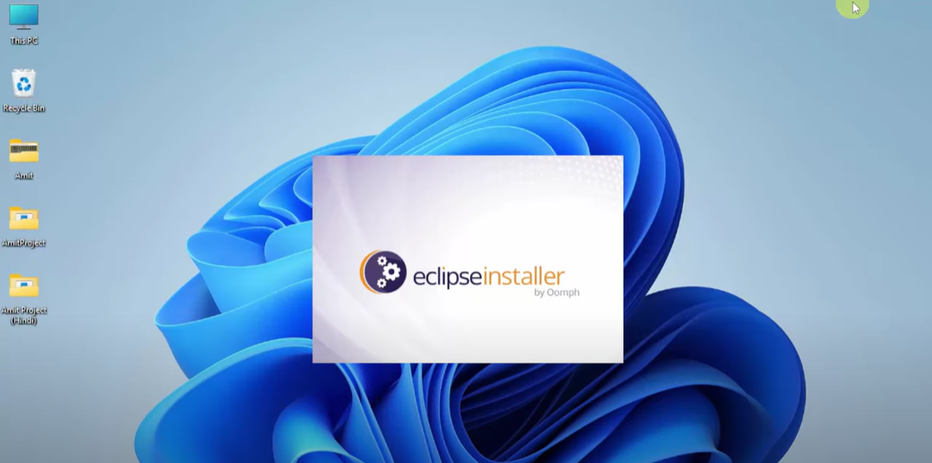

* Select eclipse IDE for java developer

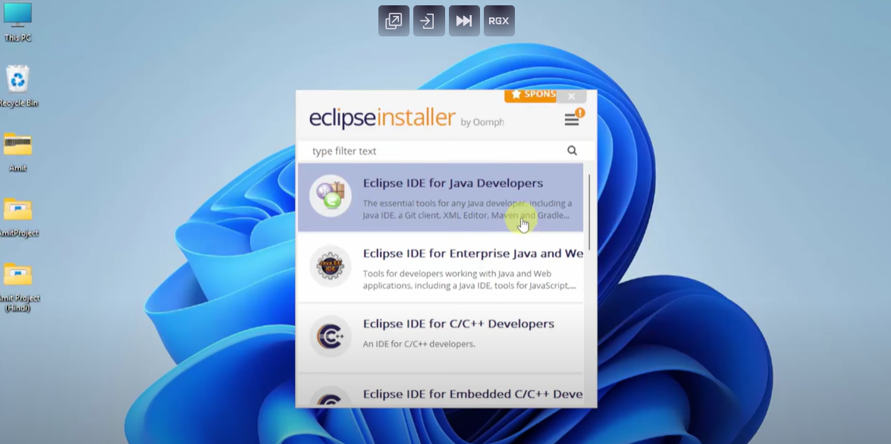

* Press on install

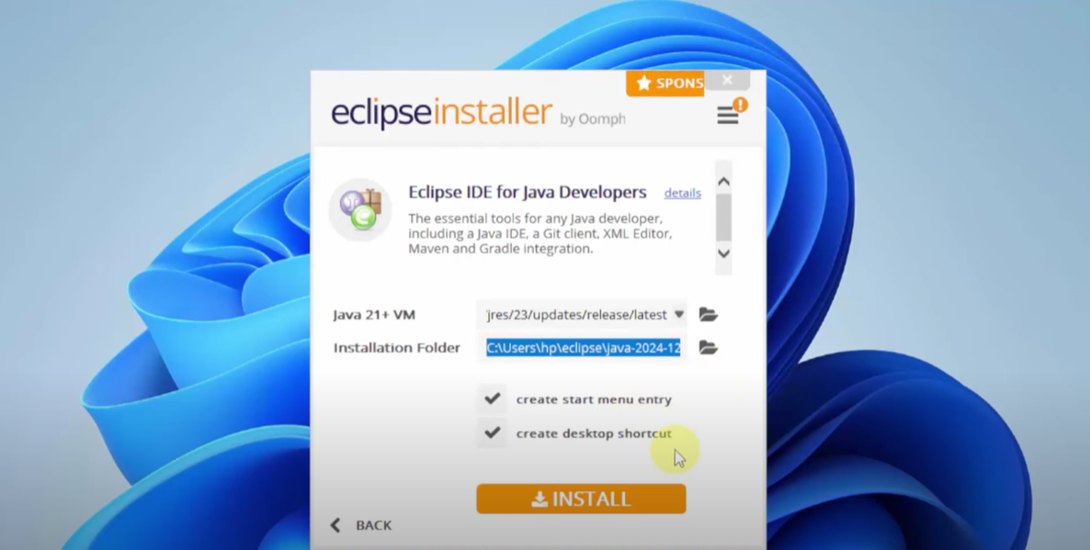

* Press accept now.

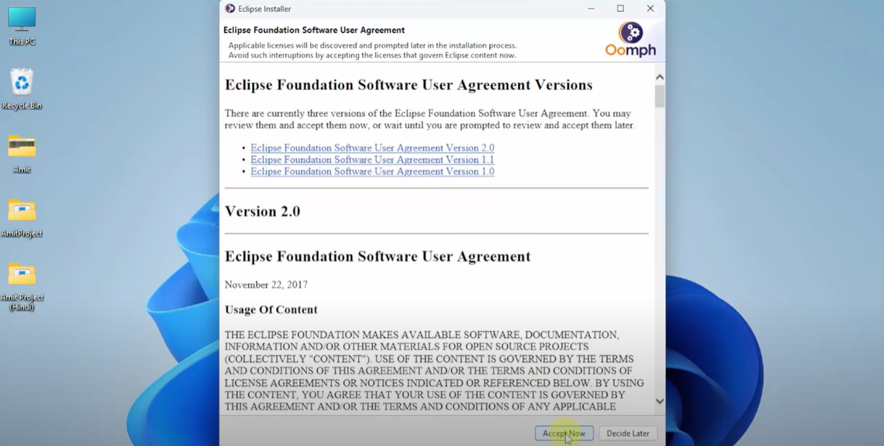

* Add your workspace directory where all your java projects will be saved and press launch.

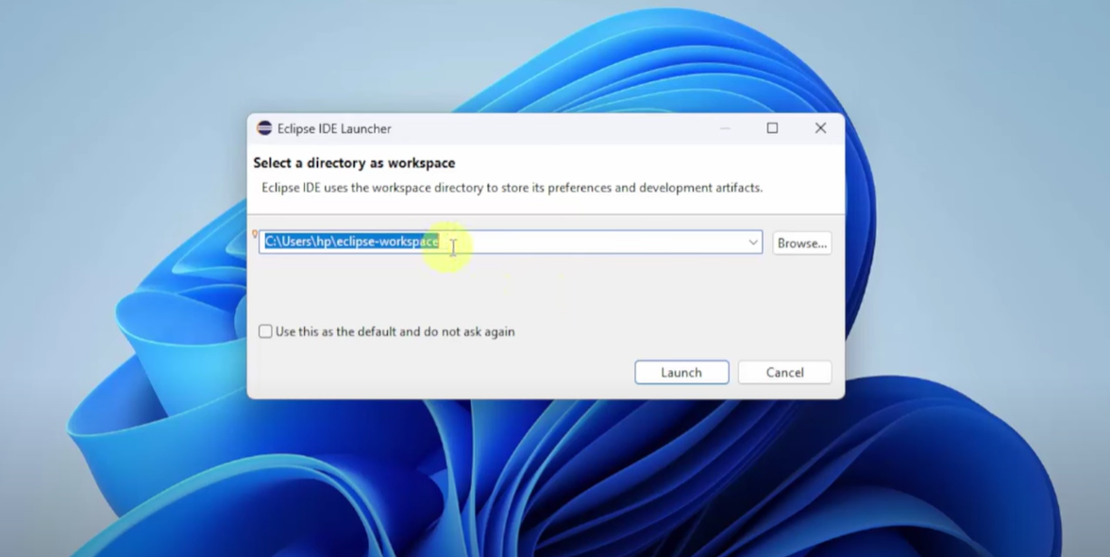

* Eclipse is installed.

